- Access to the website https://developers.openshift.com/getting-started/windows.html#client-tools and follow the instructions word by word.

- Install the following programs:
*Ruby with Ruby Installer.
*Git control version.
*rhc Ruby gem.

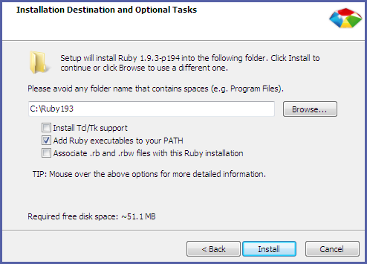

  - Install and configure gem OpenShift. Open the command console (cmd) and type the next command “C:\> gem install rhc”

- System setup. Type “C:\> rhc setup” (Press Enter to continue)

- The program will aks for Openshift user and password. After typing them click “Yes “ and “Yes”.
- Clone the Openshift project: C:\> git clone <git_url> <directory to create>

- Once cloned, import it to Eclipse. (Eclipse: import, General existing projects into workspace and in root directory type our repository path.

- This link will show us how to install and configure PUTTY on Windows to access Openshift via SSH -----https://www.youtube.com/watch?v=dZwngyEtWmU (the file SSH-2-RSA id_rsa.ppk must be generated at the end).

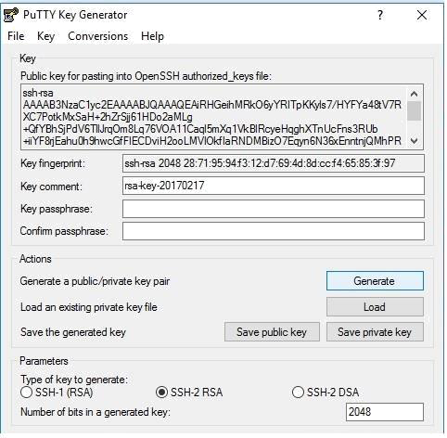

- Import the porject to Eclipse from the previously cloned folder on the system and afterwards update through Synchronize from GIT Project to Web Project.

- To update the current project through cmd console, use the next commands:
*To access Web project folder, type cd <project name>
*Git add .
*Git Commit –m “update message”
*Git push

12. If everything worked, a message will display listing the modified files and confirming that everything is OK.
13. Verify the web page to make sure the changes are correct.

